Pong

Design Documentation

River Schenck

**Table of Contents**

Table of Contents ……………………………………………………………………………………………… 1

Table of Figures ………………………………………………………………………………………………… 2

1. – Introduction ……………………………………………………………………………………………..
2. – Scope ………………………………………………………………………………………………………..
3. – Design Overview ……………………………………………………………………………………….
   1. – Requirements …………………………………………………………………………………
   2. – Dependencies …………………………………………………………………………………
   3. – Theory of Operation ……………………………………………………………………….
4. – Design Details …………………………………………………………………………………………..
5. – Testing ……………………………………………………………………………………………………..
6. – Conclusion ………………………………………………………………………………………………..
7. – Appendices ……………………………………………………………………………………………….

**Table of Figures**

Figure 1 – Set up Screen ……………………………………………………………………………………

1. **– Introduction**

This document describes a variation of the popular video game PONG, released by Atari in 1972. PONG is a two-player game which was passed on table tennis, or “ping-pong”. Each player controls the position of his paddle and uses it to keep the ball (actually a square) from escaping his half of the court. If a player fails to return the ball, his opponent is awarded a point. This first player to reach eleven points wins the game. The variation of PONG is different from the original in that it is designed to be played on a handheld PCB device.

1. **– Scope**

The document describes the software and hardware design details of the handheld video game, PONG. This includes the requirements, dependencies, theory of operation, and the testing that was performed for validation. A copy of the software code and schematics are included in appendices at the end of this document.

1. **– Design Overview**
   1. **– Requirements**

The provided requirements for the PONG video game are as follows:

1. The system shall run on an external 9V DC power supply.
2. The system shall use a 64x128 pixel LCD to display the playing surface.
3. The system shall have two buttons. One reset button and one start button.
4. The system shall have two potentiometers located near the sides of the LCD.
5. The system shall have DIP switches that set the paddle size and initial speed.
6. The playing surface shall always show the upper and lower bounds of the court.
7. When the ball is in play, the display shall show the ball, which is a minimum of 5x5 pixels and a maximum of 8x8 pixels.
8. Whenever the ball is not in play, the display shall show the score. Scores range from 0 to 11, and the font must be a minimum of 7 pixels in height.
9. Upon reset, and until the start button is pressed, the display shall indicate that the game is ready.
10. When the start button is pressed, both scores shall be set to zero and shall be displayed for two seconds. Afterwards, the ball shall be served to a player chosen at random.
11. The ball shall have a minimum speed of 100 pixels per second and a maximum speed of 200 pixels per second. The trajectory shall have one of at least 4 different angles.
12. When the ball is served, it shall have an angle chosen at random and shall travel at least three quarters of the court (192 pixels) before reaching the receiver’s paddle.
13. The ball shall ricochet off the court bounds with an angle equal to the incident angle. If the ball hits the paddle, it shall bounce with an angle based on the point of impact.
14. If a player misses a ball, his opponent shall be awarded one point and both scores shall be displayed for two seconds. If neither score is 11, play continues by serving the ball to the player who missed.
15. If one player scores 11 points, the game is over and the LCD shall show the scores until the start button is pressed.
16. The paddle size for each player shall be configured (using 2 DIP switches) to be 8 pixels wide, 12 pixels wide, 16 pixels wide or the full width of the court.
17. The initial speed of the ball shall be configured (using 2 DIP switches) to be 100, 120, 150 or 200 pixels per second. The ball speed may gradually increase as a volley progresses.
18. A sound shall be generated each time the ball is hit, missed or ricochets off the boundary. The sound for each of these three events shall be different and shall not exceed 250 milliseconds. (Typically, the ricochet has a high pitch, a hit has a lower pitch and the miss has the lowest pitch of all).
    1. **– Dependencies**

The items that this design depends on are as follows:

1. A PCB board with necessary wire traces to control an LCD, speaker, DIP switches, buttons, potentiometers and LEDs.
2. An external 5V-9V DC power source.
   1. **– Theory of Operation**

After the device is powered up, or reset, the system will display a welcome screen on a 64x128 pixel LCD with instructions on how to start a new game. See Figure 1 below which shows the welcome screen display.

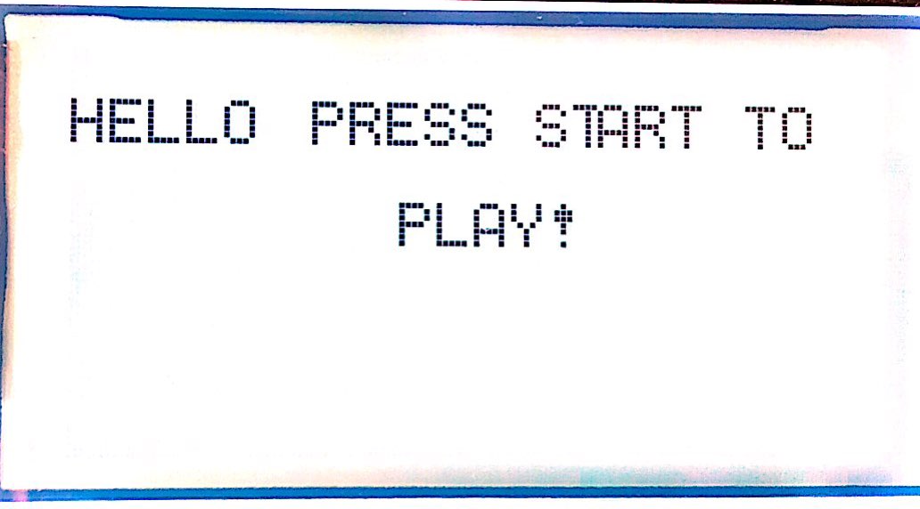

Figure 1 – Welcome Screen

Prior to game start, players will have the option to set their paddle size, game mode and ball speed using the DIP switches. After the “Start” button is pressed, the game will begin. Depending on the game mode that is chosen, the display will either show the standard PONG layout or will show the “Soccer Mode” layout which will be described in further detail later. Along with the layout, the paddles will also be displayed at the size that was chosen by the players prior to pressing the start button. See Figure 2 below which shows the initial display when in PONG mode, and the paddles are set to medium size.

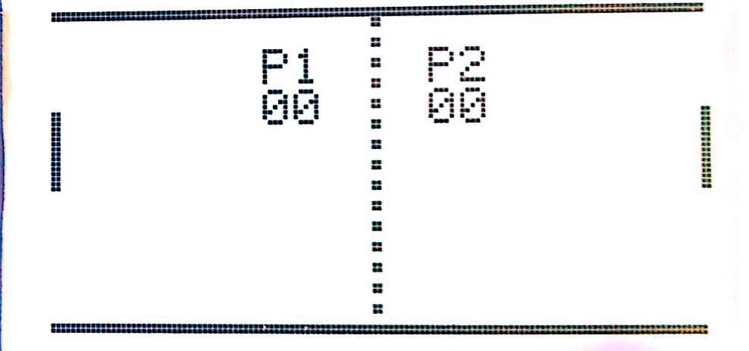

Figure 2 – Initial Display

Once the initial display has shown, player scores will disappear after two seconds and the ball (actually a 5x5 pixel square) will be served to a player at random, officially beginning the game. When the game is in play, each player will adjust the vertical position of their paddle using one of the two potentiometers located on the lower corners of the PCB. If the player is able to block the ball from exiting their side of the LCD display then the ball will ricochet off of their paddle and will then travel toward the opponent’s side. If the player is unable to block the ball, their opponent will be awarded a point and the player scores will again be displayed on the screen for two seconds. See Figure 3 below which shows the player scores that are displayed after player two has made a point.

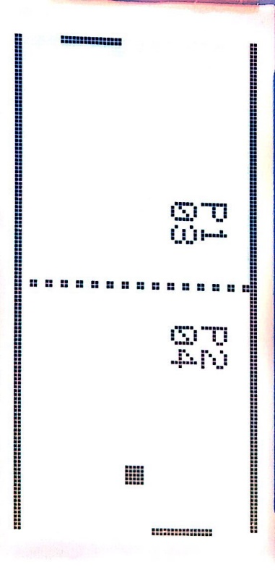

Figure 3 – Display after Player 2 Scores

The ball will then be served to the player that missed the last ball, and this process will continue until one of the two players has reached a score of eleven. The first player to reach a score of eleven will win the game, and the following set of items will occur: The player scores will be displayed on the screen; the text “Winner!” will be displayed in the center of the screen; all LEDs on the device will flash three times; three consecutive sounds will be heard to congratulate the winner. See Figure 4 below which shows the device display after a player has won the match.

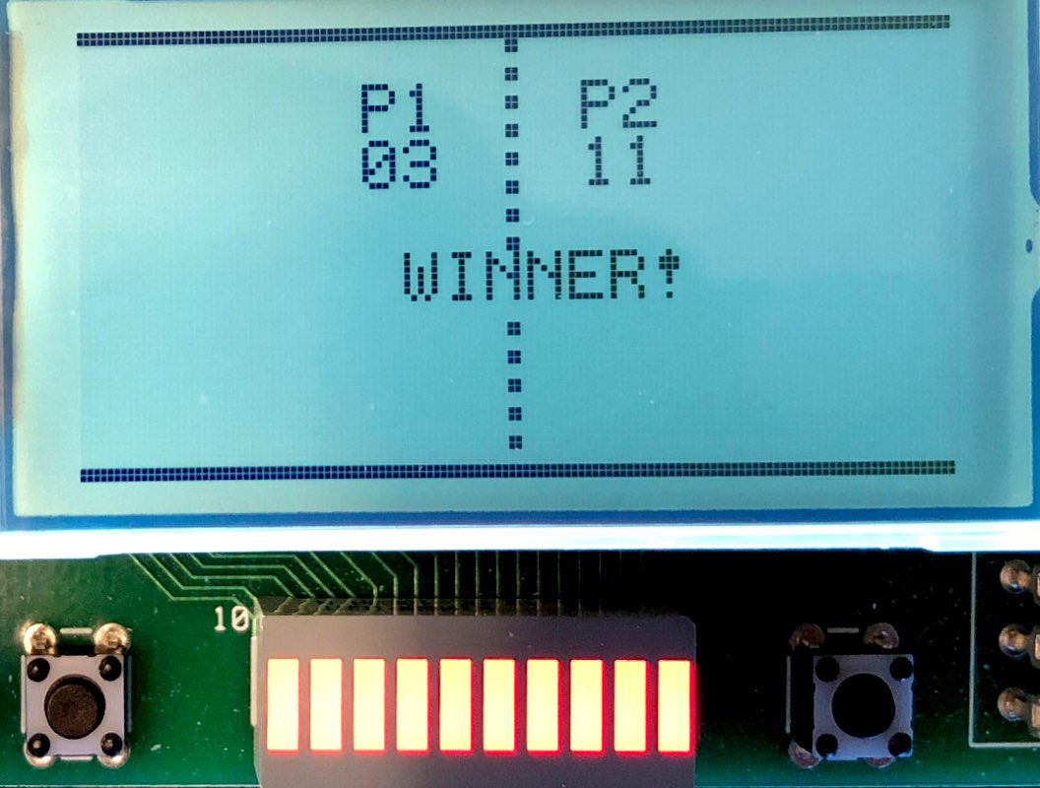

Figure 4 – Display after Player 2 Wins

When a player has won the game, and the “Winner!” sequence has completed, the game will return to the welcome screen shown in Figure 1. As mentioned above, this game also has the option to enter into “Soccer Mode”, which is activated by setting switch 5 on the DIP switches to an “off” state. If this switch has been activated, the gameplay will perform the same, but the screen display will change. In “Soccer Mode” the screen will display the layout of a soccer field, the “P1” tag will be changed to “USA”, and the “P2” tag will be changed to “ITALY”. See Figure 5 below which shows an example of the game when in “Soccer Mode”.

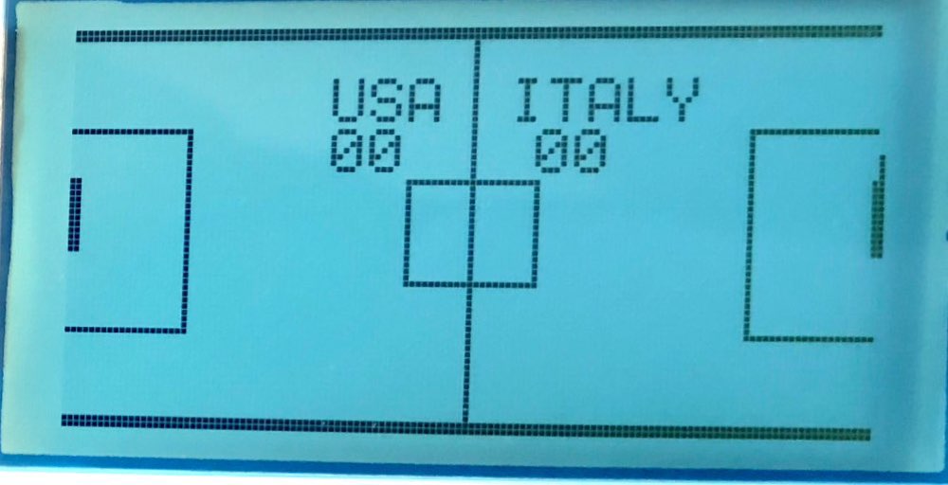

Figure 5 – Display when game is in “Soccer Mode”

Figure 6 below contains a flow chart describing the overall process for the game.

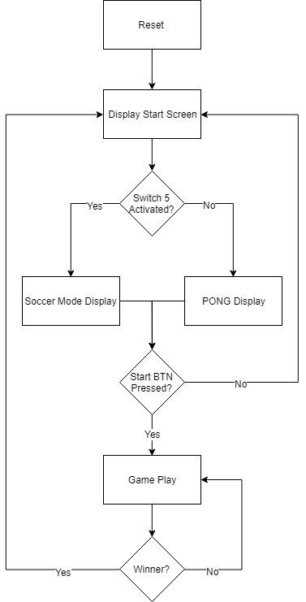

Figure 6 – PONG Top Level Flow Chart

1. **– Design Details**
   1. **– Hardware**

PONG is implemented on a C8051F020 microcontroller development board and a customized daughter board that includes the following items: LCD, two (0-50kΩ) potentiometers, two push buttons, eight 2-position DIP switches, 10 LED bar graph and a speaker. The LCD is an ST7565R (65x132) dot matrix LCD controller, which was manufactured by Sitronix. The two push buttons used are for the “start” and “reset” functions. A total of seven DIP switches are used within the PONG game. Switches one and two are used to control the paddle size for player one. Switches three and four are used to control the paddle size for player two. Switch five is used to control the “Soccer Mode” display versus the PONG display. Switches seven and eight are used to control the ball speed. The potentiometers are read via a 12-bit ADC, which is built into the C8051F020, and their values are used to display the vertical position of the paddles on the LCD. The LEDs are used as another signal (other than the score increasing) that one of the players has just made a score. Game sounds are produced by an AST-03208MR-R (8Ω) speaker and a TDA7052 amplifier. A block diagram of the hardware can be seen below in Figure 7. A more detailed schematic is found in Section 7.0 of this document, which is the Appendix.

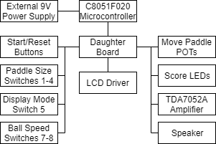

Figure 7 – Hardware Block Diagram

* 1. **– Software**

The main portion of PONG was written C, although there were some functions, including the headers, which were written in Assembly. There is an LCD driver Assembly file that controls the data and command memory within the LCD. It is within this Assembly file that the score font is also stored, which is accessed within the main PONG program. There is also an LCD header C file which initializes various functions that are created within the LCD driver Assembly file. Next, there is a PONGHEADER C file in which the variables are created, functions are called, the random serve function is taken care of, and the sound file is store. Last, there is the main PONG C file which includes multiple subroutines as follows: an initialization routine to turn on the external crystal and initialize timers; an initialize game routine which initializes and blanks the LCD, checks the switches, initializes the game, and checks the scores; a game play routine which continues the PONG game while the reset button isn’t pressed, and while neither player score is eleven, or will call the winner sequence in the case that one of the player scores is eleven; a routine that uses timer zero to create random numbers in order for a random serve as well as a random ball trajectory; a timer two routine which is used in creating the sound functions for ball impacts; a score display routine; a “Soccer Mode” routine that changes the display based on the status of DIP switch five; a routine for initializing the welcome screen text; a routine to check the DIP switches; a routine for the sound functions; a paddle movement routine; a ball speed routine; draw ball and paddle routines; a winner routine. Some of these functions will be highlighted in greater detail below, but a full copy of the program code can be found in the Appendix located in Section 7.0. Also, see Figure 8 below which lists a flow chart that the programming for this game was based on.

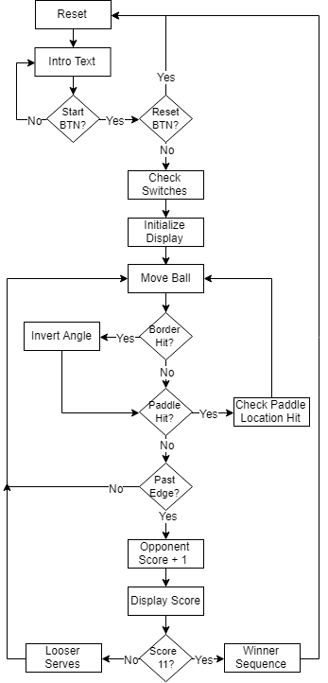

Figure 8 – Software Flow Chart

* + 1. **– RIVER**

River add what you need.

* + 1. **– RIVER**

River add what you need.

* + 1. **– RIVER**

River add what you need.

* + 1. **– RIVER**

River add what you need.

1. **– Testing** 
   1. **– Power Supply**

With a 9V power supply being among the requirements for this handheld PONG game, this output was verified in two ways. First, the transformer used to convert the AC signal from the wall into a DC signal was verified to be 9V (from the specification sticker on the transformer). Second, to verify that the specification was correct, a multi-meter was used, and a measurement of 9V DC was obtained. Another way to verify proper operation of the 9V power supply is that the PONG game functions never short the power, showing that the supply is in fact adequate.

* 1. **– LCD Display**

The LCD was also tested in multiple ways. First, after applying power to the daughter board, and in turn the LCD, the backlight turned on indicating that the device had proper power input and was ready to receive either a command or data. Next, the display was tested by sending various shapes and ASCII characters to specific locations on the LCD to verify that the proper shape or character was displayed, and that it was displayed within the correct location. Another great way that the LCD was tested to verify proper operation was by using the PONG paddles to vertically sweep the edges of the screen and ensure that the display refreshed properly. Through these tests it was verified that the LCD was operating properly.

* 1. **– Start and Reset Buttons**

In order to test the start button, the system was powered on, and the button was pressed. It is easy to verify proper operation of this button because if it is functioning properly the game will begin playing upon the first button press, otherwise there is a problem. Upon testing the button it was discovered that it was functioning without error. Similarly, when testing the reset button, the button was pressed during multiple points within the PONG game to verify that the system reset to the initial welcome display upon button press. Any time that the button was pressed during the gameplay this was in fact the case, proving that the button was in fact operating properly.

* 1. **– DIP Switches**

Since the DIP switches performed more than one function, there was multiple ways in which they were tested to verify proper operation. Starting with the paddle size switches (switches 1-4), these were tested by cycling them each through their four possibly cases, and checking the paddle size on the LCD. Switches one and two control player one paddle size, and switches three and four control player two paddle size. After running through the different cycles of each pair of switches, it was verified that the paddle size properly updated to the four different possibilities. To test switch five was a bit easier since this switch only had the purpose of activating PONG display mode or Soccer display mode. After cycling this switch it was verified that the display did in fact cycle between PONG and Soccer modes. Last, to verify the ball speed switches (switches 7-8), the switches were tested similar to the paddle size switches. The switches were cycled between the four possible ball speed values, and the ball speed increased on the LCD correspondingly. These tests verified that all of the DIP switches were in fact working properly.

* 1. **– Paddle Movement with Potentiometers**

In order to verify proper operation of the potentiometers